33

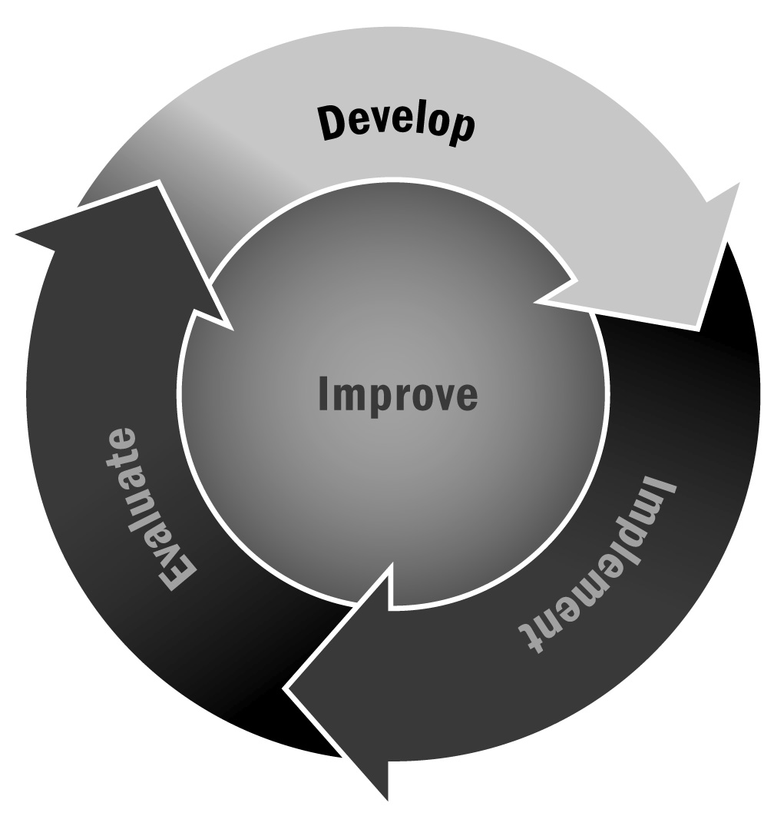
Communication Survey
In Chapter 1, you learned that assessing the effectiveness of your communication is critical to successfully communicating with key stakeholders. An easy way to assess the effectiveness of your communication is to simply ask your audience what they think of your strategy.
Directions: Use or adapt the survey on the following pages to better understand the effectiveness of your communication.

Tips for Developing and Administering Surveys (For a Full List, See Tool 87)
- Consider your goals and expected outcomes for the survey. What are you trying to learn? Design a survey and develop questions that will help you achieve those goals and answer your ultimate question.
- Make sure you are familiar with the legal and institutional requirements, if any, when surveying families, community members, and especially youth.
- Prioritize your selection of survey questions.
- Consider your audience and make sure your survey will be understood easily.
- Write short questions that respondents can read quickly and easily.
- Make sure that each question has one central idea.
- Focus your questions on suggestions for improvement rather than focusing on negative experiences.
- Avoid leading questions that appear to advocate a particular answer.
- Provide instructions on how to record answers and how many options to select.
- For multiple choice questions, allow respondents to select “Other” so that they can provide a response that wasn’t included in the options.
- Test your survey with a small group before distributing it to all of your intended respondents.
- Think about how you will deliver the survey. Will it be delivered by mail, by telephone, in person, or online? These different methods will affect the survey design. It is likely that a paper survey will be the most convenient for respondents, but an electronic survey has advantages as well (such as allowing for skip logic and requiring less data entry) if it seems like a viable format for your respondents.
- Provide respondents with a contact person whom they can reach if they have any questions or concerns about the survey.

[Program Name] Communication Survey
Dear [Respondent or Respondent Group],
This survey is intended to gain feedback on how well we are communicating with you about activities and events at [Program Name]. Your responses will remain anonymous, so please answer honestly. If you have any questions, please contact [Name] by phone (Phone Number) or email (Email Address).
- How would you rate the program’s efforts to keep you informed and involved? (Check one.)
- Excellent—I feel informed about all activities and events, and I am aware of all the ways I can get involved.
- Good—I feel generally informed about the program and its involvement opportunities.
- Fair—I occasionally receive information about the program and its involvement opportunities but feel somewhat “out of the loop” at times.
- Unsatisfactory—The program does very little to keep me informed or involved.
- How would you rate the program’s efforts to request your input about its activities? (Check one.)
- Excellent—The program regularly asks for feedback from the whole community. The program also reports to the community how it has used this input or reports why it was unable to do so.
- Good—The program asks for feedback and tries to address the issues raised by those they survey. However, the program should ask for feedback more often and/or survey other groups.
- Fair—The program asks for feedback but not often or not in a very structured way. Not much seems to change as a result of the feedback it receives.
- Unsatisfactory—The program does not ask for feedback from the community.
- How would you rate the frequency of the program’s communications about its activities and events? (Check one.)
- Just right
- Too little
- Too much
- Please provide any comments or suggestions regarding the frequency of the program’s communications about activities and events.

- Which methods of communication would you like the program to use more often when providing information about activities and events? (Check two or check “No change is needed.”)
❒ | Written newsletter | ❒ | Social media sites (e.g., Facebook, Twitter)
❒ | Online newsletter | ❒ | Radio
❒ | Newspaper | ❒ | Television
❒ | Email | ❒ | Telephone
❒ | No change is needed | ❒ | Other (specify):

- How would you rate the frequency of the program’s requests for feedback? (Check one.)
- Just right
- Too little
- Too much
- Please provide any comments or suggestions regarding the frequency of the program’s
requests for feedback.
- What methods would you like the program to use for requesting feedback? (Check two or check “No change is needed.”)
❒ | Written surveys | ❒ | Focus groups held at the program
❒ | Online surveys | ❒ | Focus groups held at another location
❒ | Telephone surveys | ❒ | One-on-one conversations
❒ | No change is needed | ❒ | Other (specify):

- What suggestions do you have for improving the program’s communications overall?
Thank you for taking the time to complete this survey.
Please mail your completed survey by [Date] to [Name] at [Address].

